Computer Networks

Lab Task 06

Name: Ahmed Kasteer

Roll Number: 20F-0336

Section: 5C

**Task 1:**

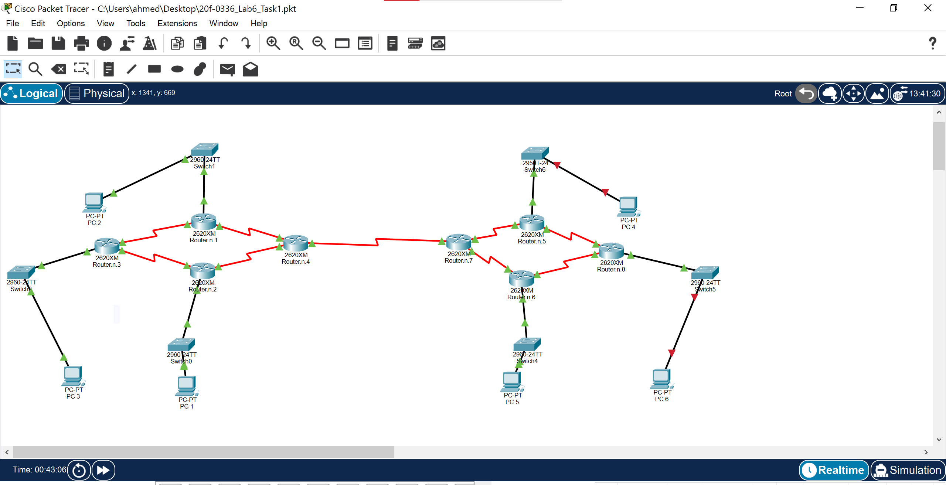

**Task 2:**

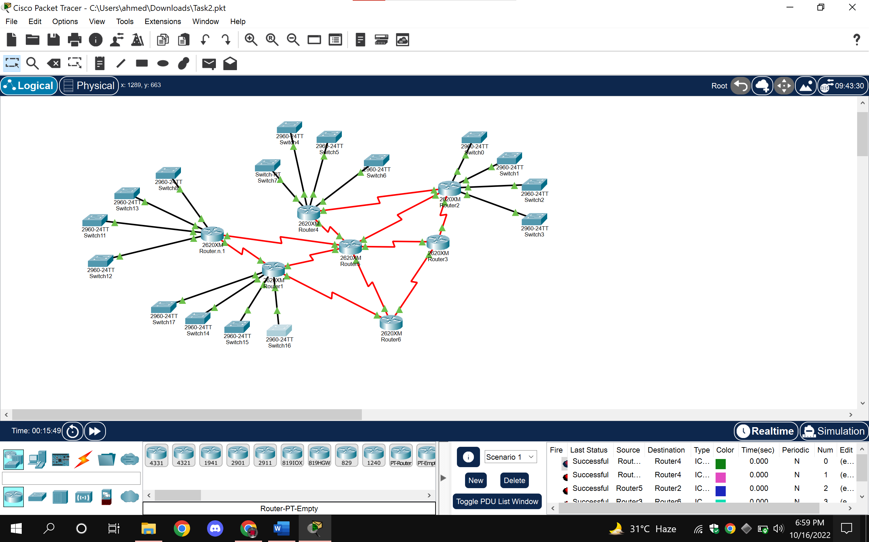

**Task 3:**

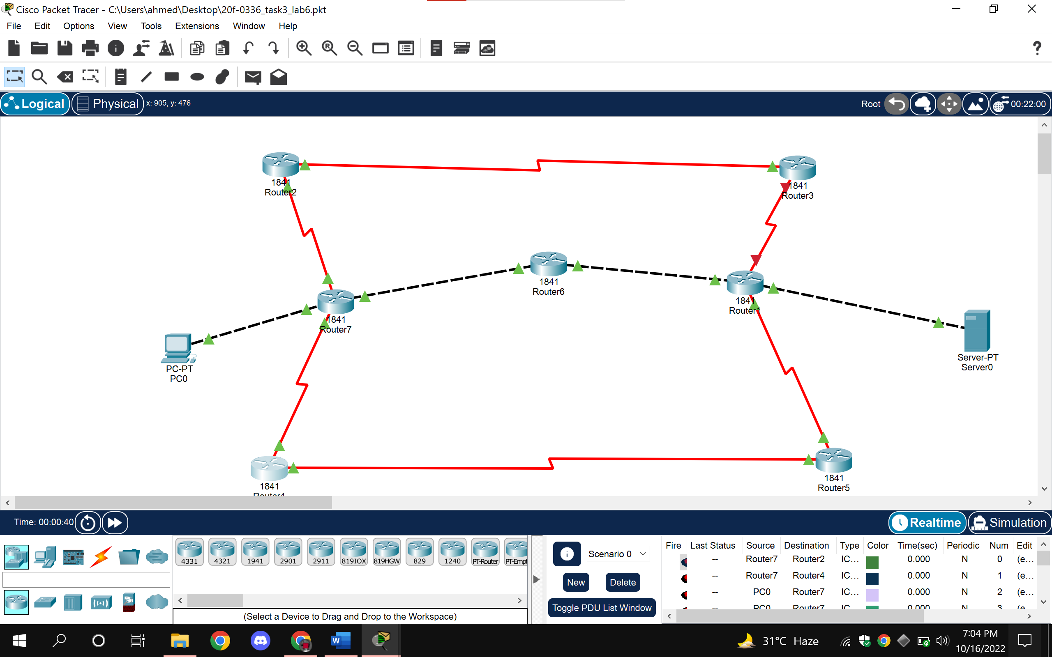

**Task 4:**

